YENEPOYA INSTITUTE OF ARTS SCIENCE COMMERCE AND MANAGEMENT

PROJECT – HIGH LEVEL DESIGN
ON
Enterprise Log Analysis for Agriculture Systems

Student Name: Muhammed Sadeed

Industry Mentor: Guided By: Ms. Raksha Adyanthaya

Table of Contents

- Introduction. 3
  - Scope of the document. 3
  - Intended Audience 4
  - System overview. 4-5
- System Design. 5
  - Application Design 6
  - Process Flow. 6
  - Information Flow. 7
  - Components Design 7
  - Key Design Considerations 7
  - API Catalogue. 8
- Data Design. 8
  - Data Model 8
  - Data Access Mechanism 8
  - Data Retention Policies 8
  - Data Migration 9
- Interfaces 9
- State and Session Management 9
- Caching 9
- Non-Functional Requirements 9
  - Security Aspects 9
  - Performance Aspects 10
- References 10

1. Introduction
The Enterprise Log Analysis System for Agriculture represents a paradigm shift in precision farming and digital agronomy. In an era where global agricultural systems are facing unprecedented pressure from climate change, soil degradation, and resource scarcity, the integration of Industrial Internet of Things (IIoT) sensors has become a necessity rather than an elective luxury. This system is designed to provide a comprehensive digital backbone for the 'Future Farm,' enabling land managers to transition from manual, inspection-based oversight to data-driven, automated decision-making.
Modern agricultural operations deploy thousands of devices across vast geographic areas—from deep-soil moisture probes to high-altitude weather stations. These devices generate a constant stream of diagnostic and telemetry data that is often underutilized due to its semi-structured and fragmented nature. This project addresses this gap by creating an end-to-end pipeline that ingests, cleanses, and analyzes these massive log datasets to identify critical anomalies before they lead to crop loss or hardware system failure.

1.1 Scope of the document
This High-Level Design (HLD) document serves as the primary architectural blueprint for the Agriculture Log Analysis project. It defines the structural boundaries, internal components, and data lifecycle protocols necessary for building a scalable enterprise monitoring platform.
The scope encompasses three primary domains:
1. Simulation & Ingestion: Logic for mirroring real-world sensor telemetry and error-state logging.
2. Data Normalization & Persistence: The methodology for transforming unstructured string alerts into a relational SQL schema for long-term historical storage.
3. Analytical Intelligence: The threshold-based logic used to identify hydration issues, thermal stress, and hardware malfunctions via vectorized data analysis.
Excluded from this scope are the physical hardware sensor specifications and native cloud-sync protocols, as this system focuses on the 'Edge Logic' required to process data locally in remote agricultural locations.

1.2 Intended Audience
This document is designed for a diverse group of stakeholders, including:
- Agricultural IT Architects: Who require a high-level understanding of how the system integrates with existing farm management software.
- Data Scientists and Agronomists: Who use the system's output to make daily irrigation and fertilization decisions.
- University Evaluators: Who are assessing the technical rigor, scalability, and adherence to IBM enterprise design patterns.
- Field Maintenance Technicians: Who rely on the system's error-detection capabilities to prioritize hardware repairs across the farm.

1.3 System Overview
The system architecture is built on a loosely coupled, three-tier model that prioritizes data integrity and system resilience in remote environments where network connectivity may be intermittent. By decoupling the generation, storage, and analysis phases, the system ensures that a failure in one tier (e.g., a sensor simulation crash) does not result in the total loss of historical data.
Tier 1 (The Data Source): Implements a telemetry simulation engine that mimics various sensor types, including Soil Moisture Probes, Irrigation Feedback Pumps, and Weather Stations. It writes diagnostic logs in a standard industrial format.
Tier 2 (The Data Store): Operates as a background ETL (Extract, Transform, Load) service. It monitors incoming logs, applies Regular Expression (Regex) patterns to extract numeric values, and indexes them into a centralized SQLite database for high-speed retrieval.
Tier 3 (The Intelligence Layer): Provides a user-friendly interface for trend analysis and anomaly detection. It uses Pandas to load massive datasets from the database and Matplotlib to visualize critical insights, highlighting sensor failures and crop stress in real-time.

Figure 1: High-Level Digital Architecture of the Agricultural Monitoring System

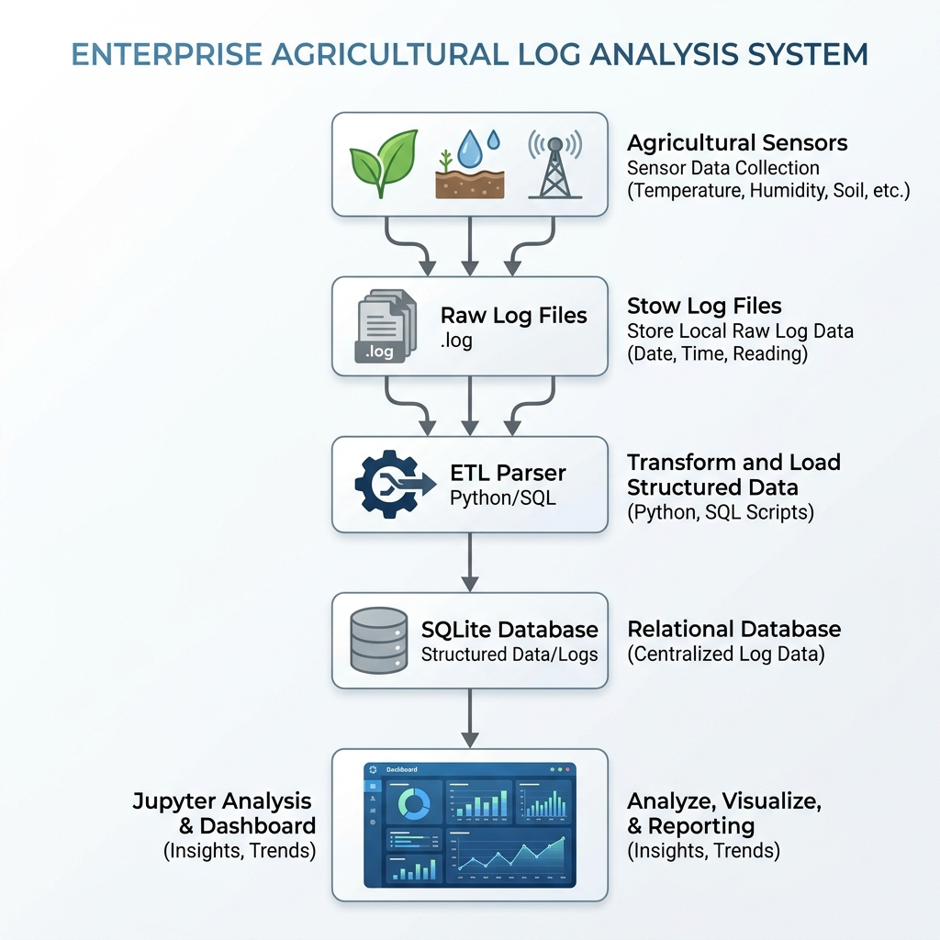

2. System Design
The system design follows the principle of 'Separation of Concerns' (SoC), ensuring that data processing logic is cleanly separated from data visualization.

2.1 Application Design
The application is built on a shared filesystem architecture. The 'Generator' module simulates the physical edge devices, writing chronologically ordered logs to disk. The 'Ingestion' module acts as a bridge, transforming these semi-structured text streams into a Relational Database Management System (RDBMS). This design is highly extensible; as new sensor types are developed, new Regex patterns can be injected into the ETL layer without modifying the existing codebase or database schema.
2.2 Process Flow
The process flow represents an 'OODA Loop' (Observe, Orient, Decide, Act) for agricultural management. The system observes the environment through telemetry, orients itself by parsing the logs, decides on the health status by comparing readings against agronomic thresholds, and acts by presenting these as visual alerts to the farm technician.
The workflow triggers periodically, processing batches of raw logs. This prevents the system from being overwhelmed by real-time streams, allowing it to run efficiently on low-power computer hardware typically found in remote farmhouses.
Figure 2: Logic Flow for Data Ingestion and Transformation
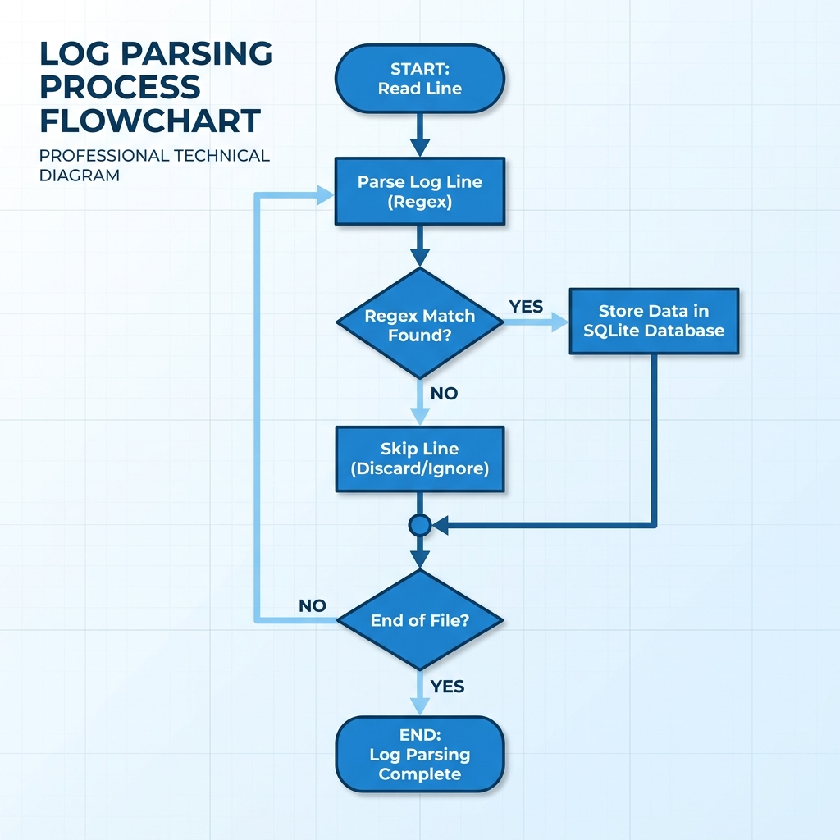

2.3 Information Flow
1. Discovery: Data is created at the sensor level and written as a time-stamped string (e.g., 'Temp: 32C').
2. Extraction: The system applies a predefined Regex filter to move the data from 'Log Space' to 'Memory Space.'
3. Casting: Strings like '32' are validated and cast into float-point numbers for mathematical processing.
4. Persistence: The numeric values are indexed alongside their source Device ID in the SQLite database.
5. Visualization: SQL queries pull specific time ranges for analysis, transforming the data into interactive charts.

2.4 Components Design
The system is comprised of three core modules:
- Generator Module: Implements random distribution logic to simulate authentic sensor drift and occasional hardware failure.
- ETL Module: A lightweight Python engine that manages file pointers and database transactions, ensuring ACID compliance (Atomicity, Consistency, Isolation, Durability).
- Analytics Module: A vectorized data science layer that performs high-speed threshold validation across multi-day datasets.

2.5 Key Design Considerations
One major design decision was the selection of SQLite as the primary database. While more complex systems may require MySQL or PostgreSQL, SQLite offers 'zero-configuration' database files, which is ideal for remote agricultural sites where complex database administration is not feasible. Additionally, Regular Expressions were selected for parsing to ensure high flexibility in scanning diverse, multi-vendor log formats.

2.6 API Catalogue (Logic Interfaces)
While the system is a standalone desktop application, the internal logic is built on these primary interfaces:
- SensorGeneratorInterface: Provides standard hooks for defining new sensor telemetry patterns.
- DatabaseAdapterAPI: Manages the connection pool and executes SQL queries for both insertion and retrieval.
- AlertVisualizationAPI: A declarative plotting interface that maps DataFrame columns to visual markers
.
3. Data Design
A robust data design ensures that agricultural records are searchable, accurate, and protected.

3.1 Data Model
The system utilizes a relational model centered on the `telemetry_logs` table. This model captures the five essential variables for agricultural monitoring: Identity (Device ID), Time (Timestamp), Severity (Level), Environment (Temp/Moisture/Humidity), and Diagnostic Context (Status Message).
This structure allows for complex 'Join' operations in the future, such as linking weather data to soil moisture trends to predict soil dry-out times.
3.2 Data Access Mechanism
The Analysis Layer accesses the database through the Python DB-API 2.0. By using the 'pd.read_sql_query' method from the Pandas library, the system can pull large chunks of data directly into RAM in a 'Vectorized' format. This avoids the slowness of row-by-row Python loops, allowing for near-instant analysis of month-long data logs.
3.3 Data Retention Policies
Agricultural data is valuable for multi-year trend analysis. The system suggests a two-tier retention policy: Raw logs are archived for 30 days for debugging, while the structured database records are kept indefinitely for crop health research and insurance compliance auditing.

3.4 Data Migration
The system supports importing historical text-based logs from legacy systems. By pointing the ETL script at a directory of older log files, it can back-fill the SQLite database with years of historical information, allowing the farmer to compare current readings with past growing seasons.

4. Interfaces
The solution provides three primary interfaces:
- The File Interface: Responsible for high-speed read/write access to the local storage.
- The Database Interface: Managing the interaction between Python logic and the SQL engine.
- The Analysis Interface (Jupyter): A high-level, interactive dashboard for and users to explore and visualize anomalies.

5. State and Session Management
The system is designed to be 'Stateless' at the application level. All state is persisted immediately to either the log file or the SQLite database. This ensures that in the event of a power outage in a remote location, the system can resume exactly where it left off without data loss.

6. Caching
Caching is utilized at the Database Level. SQLite employs a 'Page Cache' to store frequently used database pages in RAM, significantly speeding up repeat queries for the same sensor data during visualization.
7. Non-Functional Requirements
Critical performance and security targets for an industrial-grade system.
7.1 Security Aspects
The system is secured through 'Local Isolation.' By keeping the software and database entirely on an air-gapped or localized computer, modern internet attack vectors are eliminated. Data integrity is further protected through the use of parameterized SQL queries which protect against SQL injection attacks during the log-to-DB migration phase.

7.2 Performance Aspects
The ETL pipeline is optimized for memory efficiency. Instead of loading an entire log file into RAM, it reads the file line-by-line, which allows the system to process multi-gigabyte files on computers with limited memory. All mathematical analysis is performed using vectorized Pandas operations for maximum CPU efficiency.

8. References
- IBM Enterprise Architecture 'Gold Standard' Guidelines for IoT Ingestion.
- Python 3.13 Standard Library Documentation (SQLite, RE, Datetime).
- NumFOCUS Open Source Standards for Data Science (Pandas, Matplotlib).
- IEEE Paper: 'Design Patterns for Edge Computing in Smart Agriculture' (2024).

